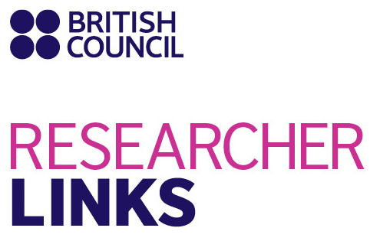 | 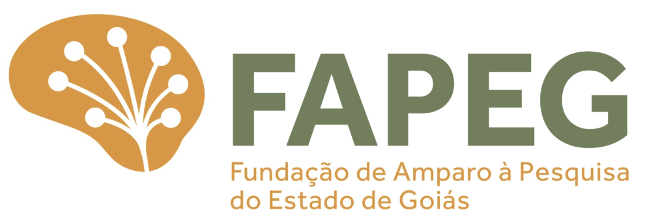 | 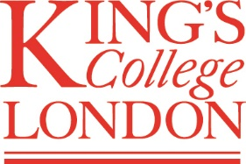 | 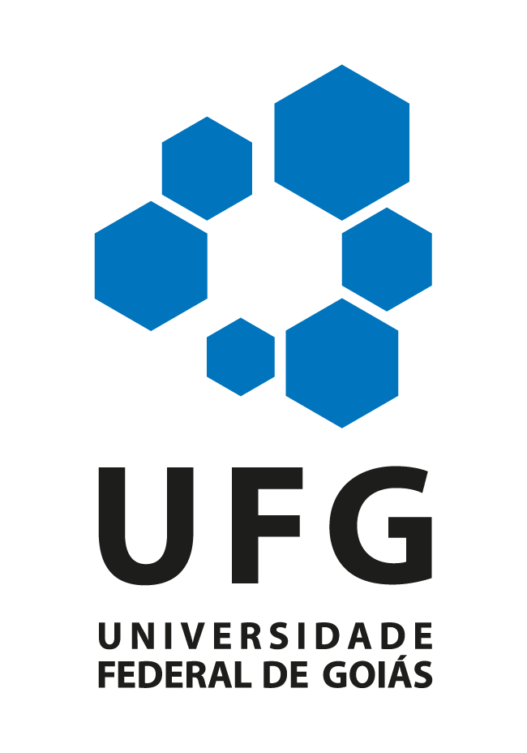

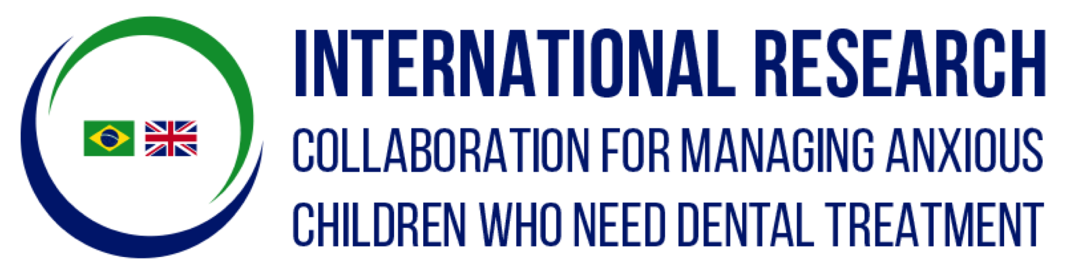

APPLICATION FORM

Workshop Title: An international research collaboration for managing anxious children who need dental treatment

UK coordinator: Prof. Marie Therese Hosey, King’s College London, UK

Partner Country coordinator: Prof. Luciane Ribeiro de Rezende Sucasas da Costa, Universidade Federal de Goiás (UFG), Brazil
Discipline: Paediatric Dentistry
Dates and venue: October 14th to 18th, 2017; Dental School/UFG, Goiânia-Goiás, Brazil

The programme, ‘British Council Researcher Links’ provides opportunities for early career researchers from the UK and internationally to interact, learn from each other and explore opportunities for building long-lasting research collaborations.

As part of this programme, we are now recruiting early career researchers to participate in the above workshop.

The workshop will provide a unique opportunity for sharing research expertise and networking. During the workshops early career researchers will have the opportunity to present their research in the form of a poster and discuss this with established researchers from the UK and partner countries. There will be a focus on building up links for future collaborations and participants selected on the basis of their research potential and ability to build longer term links.

The British Council and the Fundação de Amparo à Pesquisa do Estado de Goiás (FAPEG) will cover the costs related to the participation to the workshop, including: travel (both international and local), accommodation and meals. Costs for the visa will be covered; however participants will be responsible for making all the necessary arrangements. Although this cost will not be covered by the British Council, participants are encouraged to purchase an adequate travel and medical insurance. The British Council accepts no responsibility for any problems which may occur when the participants are in-country.

Application and Deadline:
The full application below must be completed and submitted by the deadline of 28th April 2017 to: m.t.hosey@kcl.ac.uk (UK applications) and lucianecostaufg@gmail.com (Brazil applications).

Eligibility Criteria:
- Applications must be submitted using the Researcher Links application form
- Application must be submitted before the above deadline
- Participants must be Early Career Researchers*, who have a dental degree and received their PhD degree or equivalent after 2007. *Participants have to meet the criteria for ‘R2 – Recognized Researcher’ level or at the beginning of R3 level of the European Commission (http://euraxess.ec.europa.eu/europe/career-development/training-researchers/research-profiles-descriptors). For the UK participants only: if an applicant does not hold a PhD but has recent relevant research experience equivalent to a PhD s/he can also participate.
- Participants must have a research or academic position (a permanent post, research contract, or fellowship etc.) at a recognised research institution either in the UK or in Brazil
- Please note that participants are expected to attend all sessions of the workshop

Quality Assessment
- Experience and relevance of the applicant’s research area to the workshop
- Motivation and contribution to the aims of the workshop
- Description of the long term impact expected through the participation in the workshop
- Ability to disseminate workshop’s outcomes

Selection Procedure:
- Eligibility check
- Quality assessment
Participants will be 34 early career researchers.
Participants will be selected based on their curriculum, which must prove authorship in papers published in the field of behaviour/restorative management in paediatric dentistry from 2012.
Participants will be scored according to their publication and also to: Authorship in book chapters, books and conference presentations; current link with a postgraduate program that includes a research area in paediatric dentistry. The participants with the highest scores will be selected.
Participants should reside in either Brazil or United Kingdom but, according to the Newton Funds applicant guidelines, no more than five of Early Career Researchers from either UK and Brazil may be recruited from within the institutions of the coordinators and mentors i.e. King’s College London, Universidade Federal de Goiás and Universidade de São Paulo.

Notification of results
Applicants will be notified by email 3 months prior to the workshop.

Equal Opportunities
Equal opportunities and diversity are at the heart of the British Council’s cultural relations ambitions. While recognising that some research fields are dominated by one particular gender, co-ordinators are encouraged to work towards an equal gender balance, promote diversity. They must not exclude applicants on the basis of ethnicity, gender, religious belief, sexual orientation, or disability. Participants’ selection undertaken by workshop organisers must not contravene this policy. Extra support to enable participation of Early Career Researchers with special needs will be given.

Workshop Application Form

1. Applicant
Name and title
Gender (for statistical purposes. This will not affect choice of participants)
Position and institution
Postal address
Email
Phone number
Brief CV (academic career, publications, markers of esteem, and any other relevant information) – no more than ½ page of A4

Abstract - Please give a summary of your area of research

3. Please describe your motivation for attending the workshop and how the workshop matches your professional development needs
4. Please describe the expected impact of your participation on your personal and professional development, including your ability to work internationally

5. Please indicate how you will disseminate the outcomes of the workshops and the new knowledge/skills you have acquired

6. Workshops will take place in English as standard. Please indicate your ability to work and communicate in English (Note, translators may be provided if necessary)
Native speaker |  | Good
Excellent |  | Need support

7. Please use this space to give any additional information that you feel is relevant for the application.

